SWANA 2020
GRANT H. FLINT INTERNATIONAL SCHOLARSHIP AWARDS PROGRAM
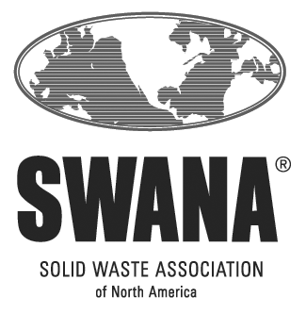

CATEGORY II –
College/University
Juniors & Seniors Studying a Field Related to Solid Waste Management

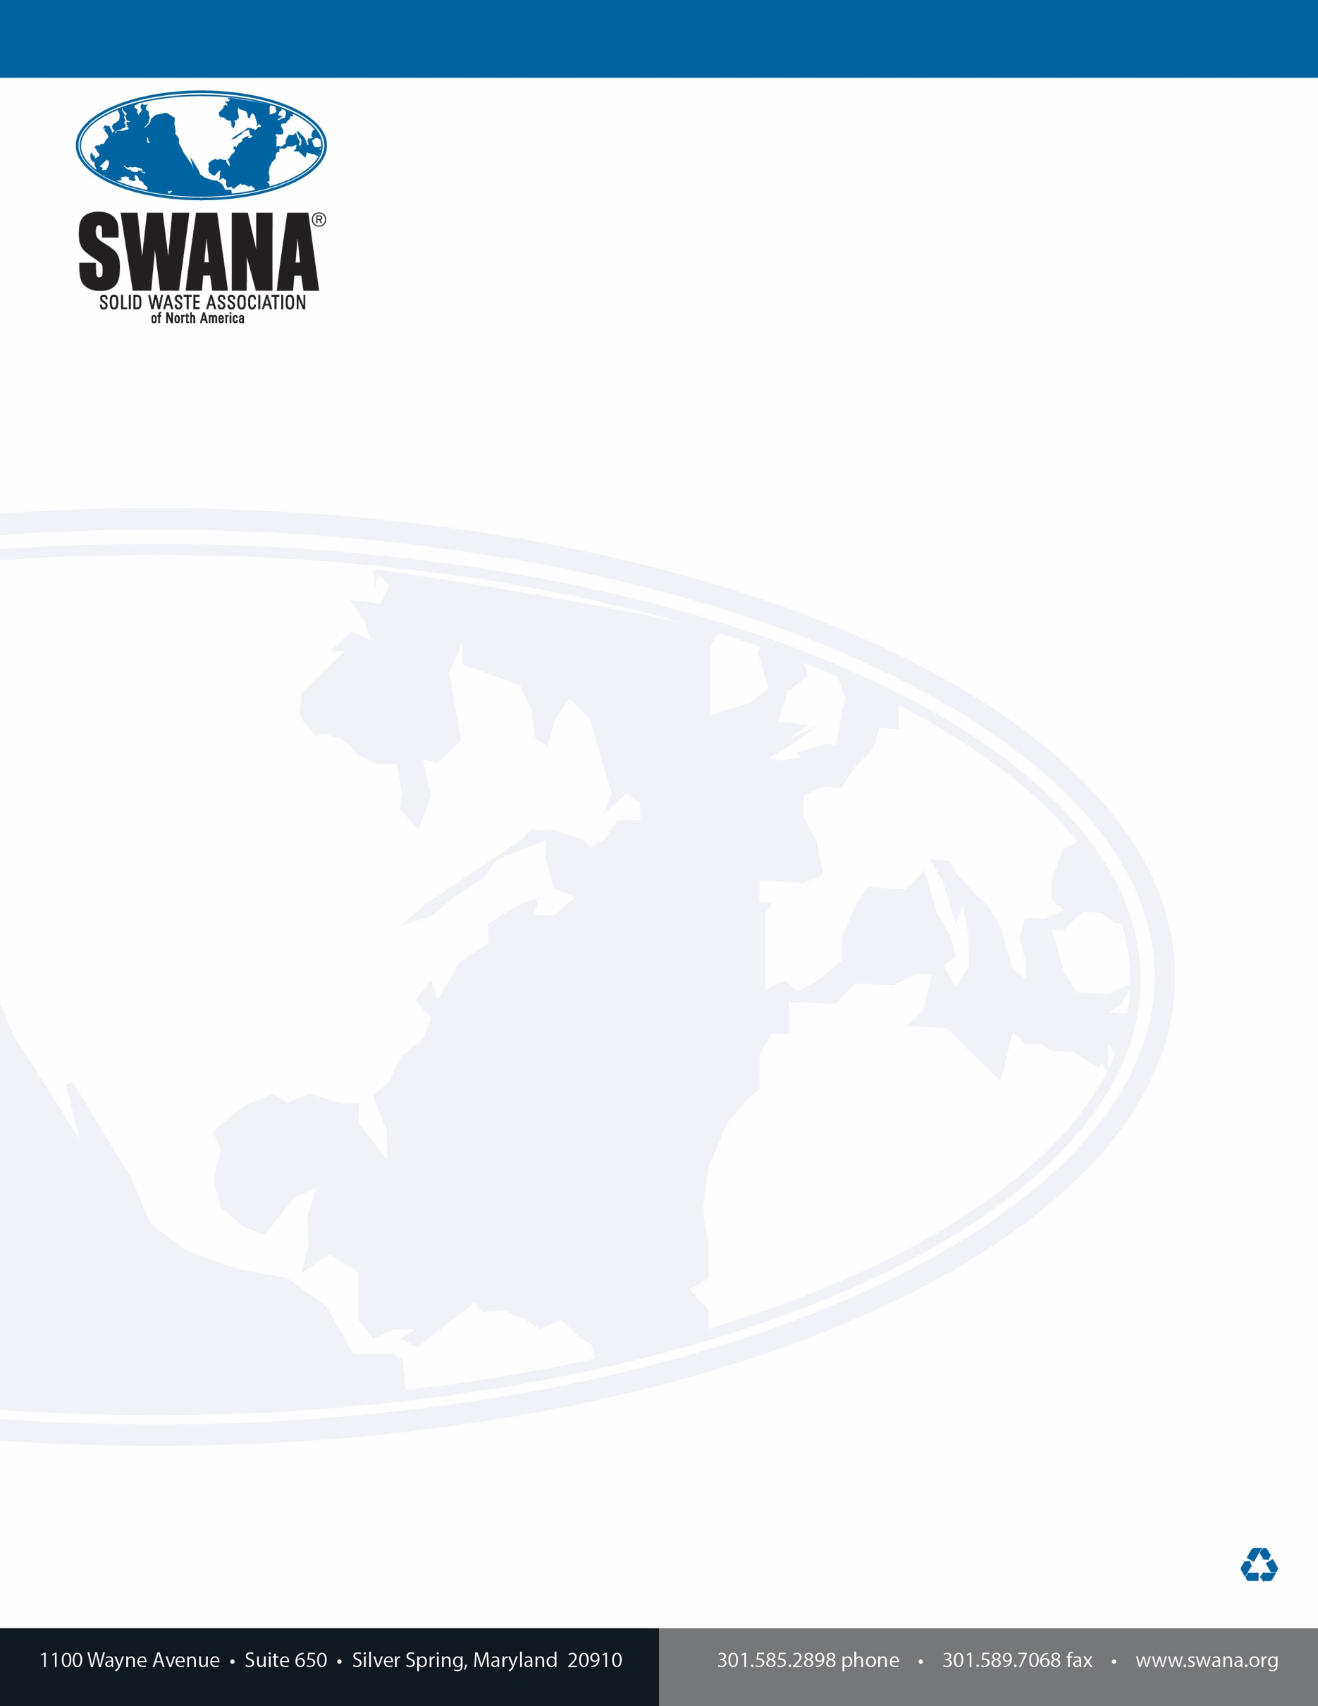

Dear College or University Junior or Senior:
Hello and thank you for your interest in SWANA’s Grant H. Flint Scholarship Awards Program.
SWANA is a professional association of more than 10,000 members who work in solid waste management. That industry is far advanced from the old stereotypes of “garbage men.” Our membership is diverse, and we encourage you to consider how your selected area of study might lead you into our professional ranks. Will you be an engineer, scientist, agency or business manager, sales professional, safety specialist, expert in communications, marketing or policy? Do you want to work as a front-line collector, equipment operator or maintenance specialist? They all help fulfill the critical function of managing solid waste as a resource and SWANA has a place for you.
To be eligible to apply for SWANA’s Category II Scholarship, worth $5,000 US, you must be:
- Enrolled full-time in college or university for the period of time the scholarship will be used
- Entering your junior or senior year of undergraduate studies
- Pursuing a degree in environmental science, environmental studies, engineering or a major applicable to the field of solid waste or resource management.
- A SWANA Student Member. This is free to full-time students and you can join by visiting www.swana.org.
Applications are due to your Chapter Scholarship Committee Chair by May 1, 2020. Chapters may award their own scholarships and are also responsible for sending a single chapter nomination for the $5,000 US Category II (College/University Junior or Senior) Scholarship to SWANA by June 1, 2020. SWANA’s awards will be announced during summer 2020.
Contact information for Chapter Scholarship Committee Chairs can be found at https://swana.org/Awards/ScholarshipsInternships.aspx. You will also find a link to many of the Chapter websites and information about their local scholarship programs.
Members living outside the United States, its territories or Canada should complete the application and send it directly to Sara Bixby in her role as SWANA’s Staff Scholarship Administrator by May 1, 2020.
For more information, check with your Chapter Scholarship Chair or Sara Bixby at sbixby@swana.org.
We look forward to receiving your application. Best of luck as you continue your education.
Sincerely,
Mike Stringer | Sara Bixby
Chair, SWANA Scholarship Committee | Deputy Executive Director, SWANA
SWANA
GRANT H. FLINT SCHOLARSHIP AWARDS PROGRAM
CATEGORY II APPLICATION INFORMATION

- AWARDS:
SWANA intends to give a Category II award of $5,000 to a rising college/university junior or senior each year. Depending on the number and quality of applications, SWANA reserves the right to give more or fewer awards in this category and to adjust the number of awards in its other scholarship categories.

- ELIGIBILILTY:
To be eligible to apply for SWANA’s Category II Scholarship, worth $5,000, you must satisfy all the following requirements:
- Be enrolled full-time in college or university for the period of time the scholarship will be used
- Be entering your junior or senior year of undergraduate studies
- Be pursuing a degree in environmental science, environmental studies, engineering or a major applicable to the field of solid waste management or sustainability.
- Be a SWANA Student Member. This is free to full-time students and you can join by visiting www.swana.org.
SWANA employees and their family members are not eligible to apply. Beyond those exceptions, SWANA commits that all eligible persons shall have equal access to this program.
DEADLINES:
- May 1 - All completed application forms and back-up documentation must be received by your Chapter Scholarship Committee Chair.
  - Students can join two chapters for free.
    - Join the chapter where your school is located. Submit your application there.
    - If you have an internship or work assignment in a different chapter area, check into their activities and programs as those new relationships can lead to additional support for your application.
  - If you are geographically located outside the United States, its territories or Canada, send your completed application directly to SWANA’s Staff Scholarship Administrator by May 1, 2020.
- June 1 – Chapters forward their nomination for the SWANA Grant H. Flint Scholarship Category II Scholarship to headquarters for distribution to the International Scholarship Committee.
- July/August - International Scholarship winners are announced.

- CRITERIA:
The Scholarship Committee evaluates the Grant H. Flint Category II Scholarship applications as follows:
- Academics = 30%
SWANA’s Scholarship Committee considers past academic performance an important selection criterion. Your application must provide enough information to allow the Scholarship Committee to evaluate your academic performance.
- REQUIRED: Provide a transcript of your college/university transcripts up to the conclusion of the most recent period (quarter, trimester, semester).
An official, unofficial or PDF copy of your transcript is required to be attached to the application you provide to the Chapter or SWANA. The transcript must provide marks for all courses and a measure of your academic performance when measured on the school’s standardized scoring system. Identify the scale used (e.g., 4.0 on a 4.0 scale). An example of one possible measure satisfying this request for U.S. based students is grade point average (GPA). SWANA acknowledges that not all schools use this measure and will accept other measures documented by the transcript.
- OPTIONAL: Attach documentation of any other college/university-level academic performance, awards, or recognition and/or letters of recommendation related to academic performance you believe the Scholarship Committee should consider.

- Relationship of Studies to Solid Waste Management = 50%
The Committee will consider your current and completed courses, advisor/professor input, and your completed essay in its evaluations.
- REQUIRED: Complete and sign the form that asks for additional information about coursework related to solid waste management and/or a potential career in the industry.

- REQUIRED: Please have your faculty advisory or a key professor in your studies related to solid waste management provide a one-page letter that discusses your academic performance.

- REQUIRED: Write a one-page, original essay about the topic identified in Question 4. SWANA considers essays as potential blog posts in its social media, regardless of selection for a Grant H. Flint Scholarship.

- Other Activities = 20%
Other Activities are activities and programs that can be connected with your studies (research, internships, assistantships), associated with school (participation student organizations), or entirely unrelated (volunteer activities, military service, employment).
- REQUIRED: Complete and sign the forms that ask for information about your Other Activities.

- OPTIONAL: Attach a current copy of your resume.
Describe what you did and how often you participated. Attach documentation and/or letters of recommendation to help the Scholarship Committee appropriately score this part of your application.

- Financial Need – not weighted
OPTIONAL: Although it is not a weighted factor, the Scholarship Committee can take financial need into consideration. Some chapters may also consider financial need in their review of applications. Please do not attach forms that contain confidential personal information.
- Disqualification
Applying is not a guarantee of funding. The Scholarship Committee may disqualify an application for any of the following reasons.
- Applicant fails to meet the May 1 deadline for submitting the application to the Chapter or Staff Scholarship Administrator
- Chapter fails to provide its recommendations to SWANA by the June 1 deadline
- Applicant will not be enrolled in classes in the coming semester
- Applicant does not provide all REQUIRED supporting documentation
- Application contains an essay or substantial parts of an essay written by another person
- Application is not legible
- Application Is not signed by the applicant where indicated

- QUESTIONS:
We realize there may be questions that aren’t answered by this overview. Please direct your questions to your Chapter’s Scholarship Chairperson, who can be found at https://swana.org/Awards/ScholarshipsInternships.aspx or for at-large applicants, to SWANA’s Staff Scholarship Administrator, Sara Bixby, at sbixby@swana.org.

SWANA
GRANT H. FLINT SCHOLARSHIP AWARDS PROGRAM
CATEGORY II APPLICATION

1 | Applicant’s Information
 | Full Name:
 | Address:
 | Telephone:
 | Email:
 | SWANA Member #:
 | Chapter Affiliation:

2 | College/University Information
 | Name of School:
 | Address:
 | Faculty Advisor name & contact information:
 | Major:
 | How does your major relate to a career in the solid waste industry?

3 | Academics = 30% of total score
 | REQUIRED: Attach a copy of your college/university transcripts through the conclusion of the most recent period (quarter, trimester, semester).
 | To aid the Committee’s review, indicate your cumulative mark or grade point average here and identify the scale used (e.g., 4.0 on a 4.0 scale), if applicable.
 | - Applicant’s GPA or cumulative score:
 | - Maximum in the scoring/scale used:
 | Optional: | Attach documentation of any other academic performance, awards, or recognition and/or letters of recommendation related to academic performance you believe the Scholarship Committee should consider.

4 | Relationship of Studies to Solid Waste Management = 50% of total score
 | REQUIRED: All three items must be included with your application.
 |  | Complete and sign the forms that ask for additional information about coursework and internships related to solid waste management and/or a potential career in the industry.
 |  | Attach a letter about your academic performance from your faculty advisor or key professor in your studies related to solid waste management.
 |  | Attach a one-page, original essay about the way in which your course work, internships, and/or overall studies will contribute to improving the management of waste as a resource or to addressing an environmental issue related to solid waste that is currently in the news.

5 | Other Activities = 20% of total score
 | REQUIRED: Complete and sign the form that asks for information about your Other Activities. Attach documentation and/or letters of support that will help the Scholarship Committee appropriately score your application. If you do not participate in Other Activities, sign the bottom of the blank page.
 | Optional: Attach a current copy of your resume.

6 | Financial Need: not weighted
 | You may attach a short statement of your financial need, describing how this scholarship will help offset tuition and related expenses and listing any other scholarships or educational funding received to-date. Please do not attach forms or other documented containing confidential personal information.

Signature of Applicant | Date

CATEGORY II
Description of Completed Courses Related to Solid Waste Management

Please provide the course title, credit hours, grade earned, and up to a 25-word description of your course work that relates to solid waste management and/or a career in the industry. Copy the page if you need more space.

Course Title:
Credit Hours:
Grade:
Description:

Course Title:
Credit Hours:
Grade:
Description:

Course Title:
Credit Hours:
Grade:
Description:

Course Title:
Credit Hours:
Grade:
Description:

I, ______________________________, verify that the information above is true to the best of my knowledge.
CATEGORY II
Current or Completed internships and Assistantships

Provide enough information to allow the Committee to what you did and its relevance to solid waste management. Please limit your description to no more than 250 words. Copy the page as needed to address additional internships and assistantships.

Internship/Assistantship
Supervisor & contact information
Description:

Internship/Assistantship
Supervisor & contact information
Description:

I, ______________________________, verify that the information above is true to the best of my knowledge.
CATEGORY II
Other Activities

Other activities are activities and programs that can be connected with your studies, school participation, or entirely unrelated (volunteer activities, military service, employment). Provide enough information that Committee members can understand your participation. Keep it brief and copy the page if you need more space.

Activity
Duration & frequency
How did you participate?

Activity
Duration & frequency
How did you participate?

Activity
Duration & frequency
How did you participate?

Activity
Duration & frequency
How did you participate?

I, ______________________________, verify that the information above is true to the best of my knowledge.

Have you attached:

- College/university transcript - required
- Documentation of academic achievement, awards, and honors – applicant specific
- All forms - required
- Letter from your faculty advisor or key professor – required
- One-page essay on the topic identified in Question 4 – required
- Resume – optional

By May 1, return your complete application to your Chapter Scholarship Chair, https://swana.org/Awards/ScholarshipsInternships.aspx , or if you are geographically located outside the United States, it territories, or Canada, send your completed application directly to SWANA’s Staff Scholarship Administrator.

